Daniel DeCarlo

Box # 107

Cairn University School of Business

CIS122 Essentials of Networking

Project # 9

Project objective:

The objective of this project is to configure a network fail back solution. This is to prepare us if our main network fails then there is a backup that will replace the broken and business can be conducted as usual.

Equipment used:

|  |  |  |  |  |
| --- | --- | --- | --- | --- |
| Equipment Description | Vendor | Vendor Item # | Retail price | Actual price (if known) |
| Router | Amazon TP-Link AC1750 Smart WiFi Router - Dual Band Gigabit Wireless Internet Routers for Home, Works with Alexa, Parental Control&QoS(Archer A7) | Wireless Router Archer A7 | $56.99 |  |
| Switch | Amazon/Cisco | CISCO SYSTEMS 16-Port Gigabit Switch (SG11016NA) | $96.00 |  |
| CAT 5E Ethernet cables (2ft) | Show Me Cables  <https://www.showmecables.com/by-category/cables/cat5e-cat6-cat7/cat5e-ethernet-cables/standard-boot-cat5e-ethernet-patch-cable> | SKU 530-02 BL | $1.10 |  |
| Windows 10 | $199.99 |  |  |  |

Detailed list of software and operating platforms used, including version numbers and licensing requirements:

* Windows 10 OS

Network diagram:

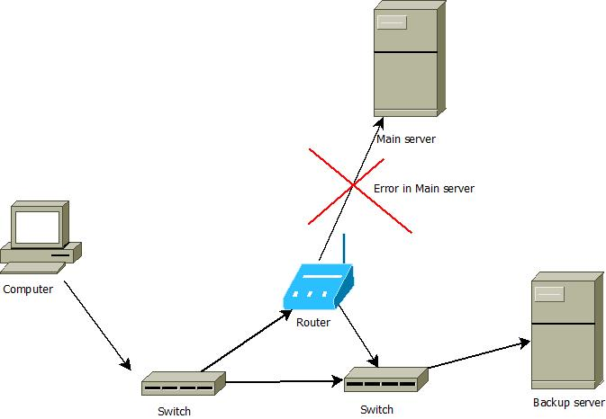

Configurations:

1. Make sure all the correct equipment is purchased and set up correctly.
2. Next go to settings and go to backups.
3. Click add drive
4. Add drive listed “Local disk D”
5. Then click manage options and choose how long you want your files to backup.
6. Also if there is an error in your main server then the switch should be directed to the backup server and operations should continue as normal.